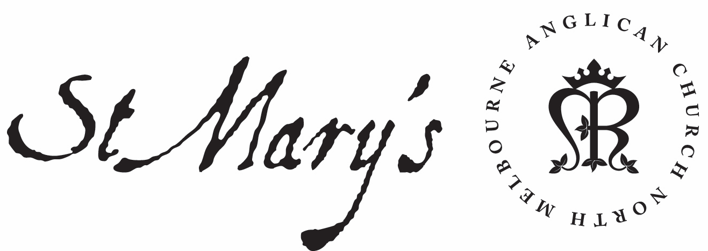
Anglican Church of Australia
Anglican Diocese of Melbourne
St Mary’s North Melbourne

Child Safe Policy

Approved by Archbishop in Council 22 March 2018
Approved by St Mary’s Anglican Church North Melbourne
Parish Council May 2018

OUR COMMITMENT TO CHILD SAFETY

This Policy is made by the Archbishop in Council of the Diocese as the governing body of the Diocese and in compliance with the requirement of Victorian legislation to meet prescribed child safe standards^{.1}

The Anglican Church of Australia within the Diocese of Melbourne, including its Cathedral Church of St Paul and each parish or congregation or faith community within the diocese (the Church) is committed to child safe practice. The care, the safety and the welfare of children are embedded in policies and practices which are intended to reflect a commitment to zero tolerance of child abuse.

When Jesus uttered his beautiful words, ‘let the children come to me and do not hinder them’ (Matt 19:14) he set the benchmark for us. We want to continue to be a Church where children and families are welcome and participate fully. We want to be an open community where people of all ages gather and interact. We want to be a Church where children and young people are fully engaged and have every opportunity to flourish and grow. We want to be a safe place and to put no barriers in place that will harm or hinder children and young people.

In all its actions and programs, we seek to maintain high ethical standards and work in accordance with child safe practices and child protection reporting guidelines. The participation and empowerment of all children is a consideration in decision-making, as we seek to provide a safe and nurturing environment where children are respected and listened to.

The Church has zero tolerance of child abuse, and all allegations and safety concerns will be treated very seriously and consistently with our robust policies and procedures. We have legal and moral obligations to contact authorities when we are worried about a child’s safety, which we follow rigorously. We are committed to preventing child abuse and identifying risks early, and removing and reducing these risks.

WHAT IS CHILD ABUSE?

What constitutes abuse and neglect is defined in the Professional Standards legislation of the Diocese and includes but is not limited to:

PHYSICAL

This means intentionally causing, or threatening to cause, physical injury to a child, or inadvertently causing injury as a consequence of physical punishment or physically aggressive treatment of a child. The injury may take the form of bruises, cuts, burns or fractures.

SEXUAL

A child is sexually abused when any person uses their authority over the child to involve the child in sexual activity. Child sexual abuse involves a wide range of sexual activity including fondling genitals, masturbation, vaginal or anal penetration by a finger, penis or any other object, voyeurism and exhibitionism.

EMOTIONAL, PSYCHOLOGICAL & SPIRiTUAL

This occurs when a person engages in inappropriate behaviour, such as rejecting, ignoring, humiliating, isolating, threatening or verbally abusing a child, or allowing others to do so. Because this kind of abuse does not leave physical injuries, it is often hidden and underestimated.

NEGLECT

The failure of a parent or guardian to provide a child with the basic necessities of life where the child has suffered, or is likely to suffer, significant harm to his or her wellbeing or development.

RACIAL, CULTURAL, RELIGIOUS

This is conduct that demonstrates contempt, ridicule, hatred or negativity towards a child because of their race, culture or religion. It may be overt, such as direct racial vilification or discrimination, or covert, such as demonstrating a lack of cultural respect (attitude and values) and awareness (knowledge and understanding) or failing to provide positive images about another culture.

TRAINING AND SUPERVISION

We, the Church are committed to regularly training and educating our office holders, staff and volunteers on child safety issues. They must all agree to abide by our Code of Conduct for Child Safety, which specifies the standards of conduct and guidelines required when working with children.
Training and education are important to ensure that everyone in the Church understands that child safety is everyone’s responsibility.
We aim to conduct training primarily through Professional Standards workshops and other forums, such as Occupational Health and Safety seminars, meetings and online information. The Church aims for all its office holders, staff and volunteers, parents and children to feel confident and comfortable in discussing any allegations of child abuse or child safety concerns. We aim to provide information to assist our office holders, staff and volunteers identify and minimise risks of child abuse.
We also support our staff and volunteers through ongoing supervision to: develop their skills to protect children from abuse; and promote the cultural safety of Aboriginal children, the cultural safety of children from linguistically and/or diverse backgrounds, and the safety of children with a disability.

RECRUITMENT

New employees and volunteers will be supervised regularly to ensure they understand the Church’s commitment to child safety and that everyone has a role to play in
protecting children from abuse, as well as checking that their behaviour towards children is safe and appropriate. Any inappropriate behaviour will be reported through appropriate channels, including the Kooyoora Office of Professional Standards the Department of Health and Human Services and Victoria Police, depending on the severity and urgency of the matter.
We will take all reasonable steps to employ skilled people to work with children. We will use selection criteria and advertisements which clearly demonstrate our commitment to child safety and an awareness of our social and legislative responsibilities. The Church understands that when recruiting staff and volunteers we have ethical as well as legislative obligations.
We actively encourage applications from Aboriginal peoples, people from culturally and/or linguistically diverse backgrounds and people with a disability.
All people engaged in child-related work, including clergy, office holders and volunteers, are required to hold a Working with Children Check and to provide evidence of this Check. We refer to the Working with Children Check website (www. workingwithchildren.vic.gov.au) for further information. They must also obtain a clearance for service from the Kooyoora Office of Professional Standards as provided in the Professional Standards legislation of the Diocese and the Clearance for Service Protocol.
The Kooyoora Office of Professional Standards carries out reference checks and police record checks to ensure that the Church appoints the right people.
If during the recruitment process a person’s records indicate a criminal history then the person will be given the opportunity to provide further information and context.
We support and respect all children. We are committed to the cultural safety of Aboriginal and Torres Strait Islander children and children from culturally and/or linguistically diverse backgrounds, as well as the safety of children with a disability. Wehave specific policies, procedures and training in place that support our leadership team, staff and volunteers to achieve these commitments.

FAIR PROCEDURES FOR PERSONNEL

The safety and wellbeing of children is our primary concern. We are also fair and just to our office holders, staff and volunteers. The decisions we make when recruiting, assessing incidents, and undertaking disciplinary and or professional standards action will always be thorough, transparent, and based on evidence.
The Kooyoora Office of Professional Standards will record all allegations of abuse and safety concerns using our incident reporting form, including investigation updates. All records are securely stored.
Under the Professional Standards legislation, an allegation of abuse is confidential and must be treated as confidential in the Church.

PRIVACY
In storing personal information, we will respect the privacy of the individuals involved, whether they are office holders, staff, volunteers, parents or children, unless there is a risk to someone’s safety. We have safeguards and practices in place to ensure any personal information is protected. Everyone is entitled to know how this information is
recorded, what will be done with it, and who will have access to it. The Professional Standards legislation prescribes these matters.

LEGISLATIVE RESPONSIBILITIES
We affirm that we must comply with applicable mandatory reporting obligations in both State legislation and the Professional Standards legislation of the Church.
Reporting child sexual abuse is a community-wide responsibility. All adults in Victoria who have a reasonable belief that an adult has committed a sexual offence against a child under 16 have an obligation to report that information to the police.
We affirm that those in the Church with the relevant power or responsibility must not negligently fail to reduce or remove the risk that a child will become the victim of a sexual offence committed by a person of or over the age of 18 years who is associated with the Church.
Through the Code of Conduct for Child Safety, the Professional Standards workshops and training, we aim to ensure that all staff and volunteers are aware of their statutory and ethical obligations.

RISK MANAGEMENT

In Victoria, organisations are required to protect children when a risk is identified (see information about failure to protect above). In addition to general occupational health and safety risks, we proactively manage risks of abuse to our children.
The Church has risk management strategies in place to identify, assess, and take steps to minimise child abuse risks, which include risks posed by physical environments (for example, any doors that can lock), and online environments (for example, no staff or volunteer is to have contact with a child in organisations on social media).
The Church is committed to systematic risk identification and management and acting to introduce measures that reduce or remove identified risk. The Church will utilize the existing risk management framework (led by the Board of the Melbourne Anglican Diocesan Corporation Ltd) to directly address and manage the risk profile. In addition to general occupational health and safety risks, we proactively manage risks of abuse to our children.

REGULAR REVIEW

The Archbishop in Council of the Diocese will review this policy and statement of commitment every two years and following significant incidents if they occur. We will ensure that families and children have the opportunity to contribute. Where possible we do our best to work with local Aboriginal communities, culturally and/or linguistically diverse communities and people with a disability.

ALLEGATIONS, CONCERNS AND COMPLAINTS

We work to ensure all children, families, staff and volunteers know what to do and who to tell if they observe abuse or are a victim, and if they notice inappropriate behaviour.
We all have a responsibility to report an allegation of abuse if we have a reasonable
belief that an incident took place (see information about failure to disclose above).
If an adult has a reasonable belief that an incident has occurred then they must report the incident. Factors contributing to reasonable belief may be:
• a child states they or someone they know has been abused (noting that sometimes the child may in fact be referring to themselves)
• behaviour consistent with that of an abuse victim is observed
• someone else has raised a suspicion of abuse but is unwilling to report it
• observing suspicious behaviour.

CHILD SAFE OFFICER
The Child Safe Officer in a parish or congregation or in the Cathedral is a point of contact for those who have questions or concerns
At St Mary’s Anglican Church, 430 Queensberry Street, North Melbourne, Victoria, 3051, the Child Safety Officer is the Office Administrator. Kerry Dehring: 03 9328 2522.

KOOYOORA Office of Professional Standards.
The Kooyoora Office of Professional Standards responds as required to all complaints of misconduct including sexual, physical, spiritual or emotional abuse by clergy or Church officers. Any reporting of abuse to the Church must be to the Director of Professional Standards at the Kooyoora office.

The first step in making a complaint is to call the recorded information line at any time on: 1800 135 246

Important contact numbers
Police 000
Child Protection 1300 360 391
Kooyoora 1800 135 246

1 Child Wellbeing and Safety Act 2005, s20, standard No 2.

