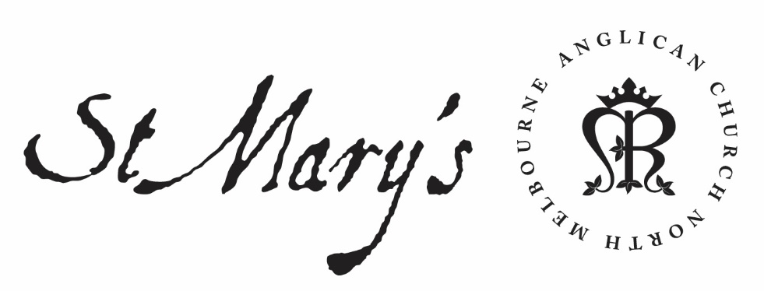

Wednesday Morning Prayer

28 October 2020
Simon and Jude

Wednesday Morning
Rejoice always; pray without ceasing;
in everything give thanks;
for this is the will of God in Christ Jesus.
1 Thessalonians 5.16–18

Glory to God; Father, Son and Holy Spirit:
as in the beginning, so now, and for ever. Amen.

The Opening Canticle, A Song of God’s Grace
Blessed are you,
the God and Father of our Lord Jesus Christ:
for you have blessed us in Christ Jesus
with every spiritual blessing in the heavenly places.
You chose us to be yours in Christ
before the foundation of the world:
that we should be holy and blameless before you.
In love you destined us to be your children,
through Jesus Christ:
according to the purpose of your will,
To the praise of your glorious grace:
which you freely bestowed on us in the Beloved.
Ephesians 1.3–6

The Opening Prayer
The night has passed and the day lies open before us;
let us pray with one heart and mind.

As we rejoice in the gift of this new day,
so may the light of your presence, O God,
set our hearts on fire with love for you;
now and for ever.
Amen.

Psalms 125; 126
Psalm 125
¹ Those who put their trust in the Lord
shall be as Mount Zion:
which cannot be shaken, but endures for ever.
² As the mountains stand about Jerusalem,
so stands the Lord about his people:
from this time forward for evermore.
³ For the sceptre of wickedness shall have no sway
over the land apportioned to the righteous:
lest the righteous set their hands to do evil.
⁴ Do good, O Lord, to those who are good:
to those that are upright in heart.
⁵ As for those who turn aside to crooked ways,
let the Lord lead them away with the evildoers:
and in Israel let there be peace.

Psalm 126
¹ When the Lord turned again the fortunes of Zion:
then were we like those restored to life.
² Then was our mouth filled with laughter:
and our tongue with singing.
³ Then said they among the heathen:
‘The Lord has done great things for them.’
⁴ Truly the Lord has done great things for us:
and therefore we rejoiced.
⁵ Turn again our fortunes, O Lord:
as the streams return to the dry south.
⁶ Those who sow in tears:
shall reap with songs of joy.
⁷ They that go out weeping, bearing the seed:
shall come again in gladness,
bringing their sheaves with them.

We consecrate this day to your service, O Lord; may all our thoughts, words, and actions be well-pleasing to you and serve the good of our brothers and sisters; through Jesus Christ, our Lord. Amen.

1st Reading
Jeremiah 3: 11-18
The Lord said to me, “Faithless Israel is more righteous than unfaithful Judah. Go, proclaim this message toward the north:
“‘Return, faithless Israel,’ declares the Lord,
‘I will frown on you no longer,
for I am faithful,’ declares the Lord,
‘I will not be angry forever.
Only acknowledge your guilt—
you have rebelled against the Lord your God,
you have scattered your favours to foreign gods
under every spreading tree,
and have not obeyed me,’”
declares the Lord.
“Return, faithless people,” declares the Lord, “for I am your husband. I will choose you—one from a town and two from a clan—and bring you to Zion. Then I will give you shepherds after my own heart, who will lead you with knowledge and understanding. In those days, when your numbers have increased greatly in the land,” declares the Lord, “people will no longer say, ‘The ark of the covenant of the Lord.’ It will never enter their minds or be remembered; it will not be missed, nor will another one be made. At that time they will call Jerusalem The Throne of the Lord, and all nations will gather in Jerusalem to honour the name of the Lord. No longer will they follow the stubbornness of their evil hearts. In those days, the people of Judah will join the people of Israel, and together they will come from a northern land to the land I gave your ancestors as an inheritance.

2nd Reading
Ephesians 2: 11-22
Jew and Gentile Reconciled Through Christ
Therefore, remember that formerly you who are Gentiles by birth and called “uncircumcised” by those who call themselves “the circumcision” (which is done in the body by human hands)— remember that at that time you were separate from Christ, excluded from citizenship in Israel and foreigners to the covenants of the promise, without hope and without God in the world. But now in Christ Jesus you who once were far away have been brought near by the blood of Christ.

For he himself is our peace, who has made the two groups one and has destroyed the barrier, the dividing wall of hostility, by setting aside in his flesh the law with its commands and regulations. His purpose was to create in himself one new humanity out of the two, thus making peace, and in one body to reconcile both of them to God through the cross, by which he put to death their hostility. He came and preached peace to you who were far away and peace to those who were near. For through him we both have access to the Father by one Spirit.

Consequently, you are no longer foreigners and strangers, but fellow citizens with God’s people and also members of his household, built on the foundation of the apostles and prophets, with Christ Jesus himself as the chief cornerstone. In him the whole building is joined together and rises to become a holy temple in the Lord. And in him you too are being built together to become a dwelling in which God lives by his Spirit.

May your word live in us
and bear much fruit to your glory.

The Canticle, Te Deum Laudamus
We praise you, O God:
we acclaim you as Lord.
All creation worships you:
the Father everlasting.
To you all angels, all the powers of heaven:
the cherubim and seraphim, sing in endless praise:
Holy, holy, holy Lord, God of power and might:
heaven and earth are full of your glory.
The glorious company of apostles praise you:
The noble fellowship of prophets praise you.
The white-robed army of martyrs praise you:
Throughout the world, the holy Church acclaims you:
Father, of majesty unbounded:
your true and only Son, worthy of all praise,
the Holy Spirit, advocate and guide.
You, Christ, are the King of glory:
the eternal Son of the Father.
When you took our flesh to set us free:
you humbly chose the virgin’s womb.
You overcame the sting of death:
and opened the kingdom of heaven to all believers.
You are seated at God’s right hand in glory:
We believe that you will come to be our judge.
Come then, Lord, and help your people,
bought with the price of your own blood:
and bring us with your saints
to glory everlasting.

Lord have mercy.
Christ have mercy.
Lord have mercy.

The Lord’s Prayer and the Collect of the Day
Our Father in heaven,
hallowed be your name,
your kingdom come,
your will be done,
on earth as in heaven.
Give us today our daily bread.
Forgive us our sins
as we forgive those who sin against us.
Save us from the time of trial
and deliver us from evil.
For the kingdom, the power, and the glory are yours
now and for ever. Amen.

Simon & Jude, Apostles & Martyrs
Almighty God,
you have built your Church
on the foundation of the apostles and prophets,
with Jesus Christ himself as the chief cornerstone:
we thank you for the apostles Simon and Jude,
and we pray that we may reveal your love and mercy,
and being joined in unity of spirit
may grow into a holy temple, acceptable to you;
through our Lord and Saviour Jesus Christ,
who lives and reigns with you and the Holy Spirit,
one God, for ever and ever. Amen.

Intercessions and Thanksgivings may be made according to local custom and need.

The Morning Collect
Eternal God and Father,
by whose power we are created
and by whose love we are redeemed;
guide and strengthen us by your Spirit,
that we may give ourselves to your service,
and live this day in love
to one another and to you;
through Jesus Christ our Lord.
Amen.

The Lord be with you.
And also with you.
Let us praise the Lord.
Thanks be to God.

May the God of steadfastness and encouragement grant us to live in such harmony with one another in accord with Christ Jesus, that we may with one voice glorify our God and Father. Amen.
Romans 15.5–6

