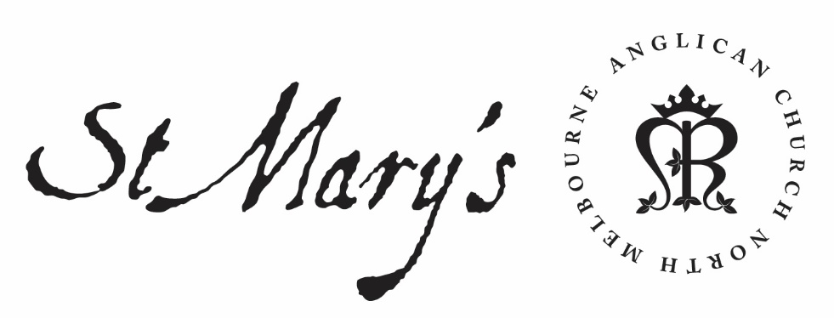

Friday Morning Prayer

30 October 2020

Friday Morning
Through Christ let us offer up a sacrifice of praise to God,
the fruit of lips that acknowledge his name.
Hebrews 13.15

Glory to God; Father, Son and Holy Spirit:
as in the beginning, so now, and for ever. Amen.

The Opening Canticle, A Song of God’s Grace
We have complete freedom:
to go into the most holy place by means of the death of Jesus.
He opened for us a new way, a living way:
through the curtain, through his own body.
Since we have a great high priest
set over the household of God:
let us draw near with a sincere heart and a sure faith,
With hearts that have been made clean
from a guilty conscience:
and bodies washed with pure water.
Hebrews 10.19–22

The Opening Prayer
The night has passed and the day lies open before us;
let us pray with one heart and mind.

As we rejoice in the gift of this new day,
so may the light of your presence, O God,
set our hearts on fire with love for you;
now and for ever.
Amen.

Psalms 148, 149

Psalm 148
¹ Praise the Lord, praise the Lord from heaven:
O praise him in the heights.
² Praise him, all his angels:
O praise him, all his host.
³ Praise him, sun and moon:
praise him, all you stars of light.
⁴ Praise him, you highest heaven:
and you waters that are above the heavens.
⁵ Let them praise the name of the Lord:
for he commanded and they were made.
⁶ He established them for ever and ever:
he made an ordinance which shall not pass away.
⁷ O praise the Lord from the earth:
praise him, you sea-monsters and all deeps;
⁸ Fire and hail, mist and snow:
and storm-wind fulfilling his command;
⁹ Mountains and all hills:
fruit trees and all cedars;
¹⁰ Beasts of the wild, and all cattle:
creeping things and winged birds;
¹¹ Kings of the earth, and all peoples:
princes, and all rulers of the world;
¹² Young men and maidens:
old folk and children together.
¹³ Let them praise the name of the Lord:
for his name alone is exalted.
¹⁴ His glory is above earth and heaven:
and he has lifted high the horn of his people.
¹⁵ Therefore he is the praise of all his servants:
of the children of Israel, a people that is near him. Praise the Lord.

Psalm 149
¹ O praise the Lord, and sing to the Lord a new song:
O praise him in the assembly of the faithful.
² Let Israel rejoice in him that made him:
let the children of Zion be joyful in their king.
³ Let them praise him in the dance:
let them sing his praise with timbrel and with harp.
⁴ For the Lord takes delight in his people:
he adorns the meek with his salvation.
⁵ Let his faithful ones exult in his glory:
let them sing for joy upon their beds.
⁶ Let the high praises of God be in their mouths:
and a two-edged sword in their hands,
⁷ To execute vengeance on the nations:
and chastisement upon the peoples,
⁸ To bind their kings in chains:
and their nobles with fetters of iron,
⁹ To visit upon them the judgement that is decreed:
such honour belongs to all his faithful servants.
Praise the Lord.

Holy God, through your beloved Son you reconciled all things to yourself, making peace by the blood of his cross: fill us and those for whom we pray with your peace and joy; through Jesus Christ our Lord. Amen.

1st Reading
Nehemiah 6:10-7:4
One day I went to the house of Shemaiah son of Delaiah, the son of Mehetabel, who was shut in at his home. He said, “Let us meet in the house of God, inside the temple, and let us close the temple doors, because men are coming to kill you—by night they are coming to kill you.”

But I said, “Should a man like me run away? Or should someone like me go into the temple to save his life? I will not go!” I realized that God had not sent him, but that he had prophesied against me because Tobiah and Sanballat had hired him. He had been hired to intimidate me so that I would commit a sin by doing this, and then they would give me a bad name to discredit me.

Remember Tobiah and Sanballat, my God, because of what they have done; remember also the prophet Noadiah and how she and the rest of the prophets have been trying to intimidate me. So the wall was completed on the twenty-fifth of Elul, in fifty-two days.

Opposition to the Completed Wall
When all our enemies heard about this, all the surrounding nations were afraid and lost their self-confidence, because they realized that this work had been done with the help of our God.

Also, in those days the nobles of Judah were sending many letters to Tobiah, and replies from Tobiah kept coming to them. For many in Judah were under oath to him, since he was son-in-law to Shekaniah son of Arah, and his son Jehohanan had married the daughter of Meshullam son of Berekiah. Moreover, they kept reporting to me his good deeds and then telling him what I said. And Tobiah sent letters to intimidate me.

After the wall had been rebuilt and I had set the doors in place, the gatekeepers, the musicians and the Levites were appointed. I put in charge of Jerusalem my brother Hanani, along with Hananiah the commander of the citadel, because he was a man of integrity and feared God more than most people do. I said to them, “The gates of Jerusalem are not to be opened until the sun is hot. While the gatekeepers are still on duty, have them shut the doors and bar them. Also appoint residents of Jerusalem as guards, some at their posts and some near their own houses.”

The List of the Exiles Who Returned
Now the city was large and spacious, but there were few people in it, and the houses had not yet been rebuilt.

2nd Reading
Matthew 20:1-16
The Parable of the Workers in the Vineyard
“For the kingdom of heaven is like a landowner who went out early in the morning to hire workers for his vineyard. He agreed to pay them a denarius for the day and sent them into his vineyard.
“About nine in the morning he went out and saw others standing in the marketplace doing nothing. He told them, ‘You also go and work in my vineyard, and I will pay you whatever is right.’ So they went.
“He went out again about noon and about three in the afternoon and did the same thing. About five in the afternoon he went out and found still others standing around. He asked them, ‘Why have you been standing here all day long doing nothing?’
“‘Because no one has hired us,’ they answered.
“He said to them, ‘You also go and work in my vineyard.’
“When evening came, the owner of the vineyard said to his foreman, ‘Call the workers and pay them their wages, beginning with the last ones hired and going on to the first.’
“The workers who were hired about five in the afternoon came and each received a denarius. So when those came who were hired first, they expected to receive more. But each one of them also received a denarius. When they received it, they began to grumble against the landowner. ‘These who were hired last worked only one hour,’ they said, ‘and you have made them equal to us who have borne the burden of the work and the heat of the day.’
“But he answered one of them, ‘I am not being unfair to you, friend. Didn’t you agree to work for a denarius? Take your pay and go. I want to give the one who was hired last the same as I gave you. Don’t I have the right to do what I want with my own money? Or are you envious because I am generous?’
“So the last will be first, and the first will be last.”

May your word live in us
and bear much fruit to your glory.

The Canticle, Saviour of the World
Jesus, Saviour of the world,
come to us in your mercy:
we look to you to save and help us.
By your cross and your life laid down,
you set your people free:
we look to you to save and help us.
When they were ready to perish,
you saved your disciples:
we look to you to come to our help.
In the greatness of your mercy,
loose us from our chains:
forgive the sins of all your people.
Make yourself known as our saviour
and mighty deliverer:
save and help us that we may praise you.
Come now and dwell with us, Lord Christ Jesus:
hear our prayer and be with us always.
And when you come in your glory:
make us to be one with you
and to share the life of your kingdom.

Lord have mercy.
Christ have mercy.
Lord have mercy.

The Lord’s Prayer and the Collect of the Day
Our Father in heaven,
hallowed be your name,
your kingdom come,
your will be done,
on earth as in heaven.
Give us today our daily bread.
Forgive us our sins
as we forgive those who sin against us.
Save us from the time of trial
and deliver us from evil.
For the kingdom, the power, and the glory are yours
now and for ever. Amen.

Twenty-First Sunday After Pentecost
O God,
whose Son has taught us that love is the fulfilment of your law:
stir up within us the fire of your Holy Spirit,
and pour into our hearts your greatest gift of love,
so that we may love you with our whole being,
and our neighbours as ourselves;
through Jesus Christ our Lord,
who lives and reigns with you and the Holy Spirit,
one God, now and for ever. Amen.

Intercessions and Thanksgivings may be made according to local custom and need.

The Morning Collect
Eternal God and Father,
by whose power we are created
and by whose love we are redeemed;
guide and strengthen us by your Spirit,
that we may give ourselves to your service,
and live this day in love
to one another and to you;
through Jesus Christ our Lord.
Amen.

The Lord be with you.
And also with you.
Let us praise the Lord.
Thanks be to God.

Peace be to us all, and love with faith, from God the Father and the Lord Jesus Christ.
Amen.
Ephesians 6.23

