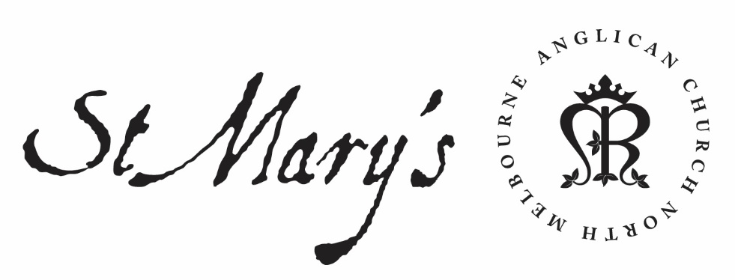

Monday Morning Prayer

11 January 2021

Monday Morning
God’s love has been poured into our hearts,
through the Holy Spirit who has been given to us.
Romans 5.5

Glory to God; Father, Son and Holy Spirit:
as in the beginning, so now, and for ever. Amen.

The Opening Canticle
I will sing a new hymn to my God:
O Lord you are great and marvellous,
you are marvellous in your strength, invincible.
Let the whole creation serve you:
for you spoke and all things came to be;
You sent out your Spirit and it formed them:
no one can resist your voice.
Mountains and seas are stirred to their depths:
rocks melt like wax at your presence;
But to those who revere you:
you still show mercy.
Judith 16.13–15

The Opening Prayer
The night has passed and the day lies open before us;
let us pray with one heart and mind.

As we rejoice in the gift of this new day,
so may the light of your presence, O God,
set our hearts on fire with love for you;
now and for ever.
Amen.

Psalms 28; 29

Psalm 28
¹ To you will I cry, O Lord my Rock,
be not deaf to my prayer:
lest, if you turn away silent,
I become like those that go down to the grave.
² Hear the voice of my supplication
when I cry to you for help:
when I lift up my hands
toward the holiest place of your sanctuary.
³ Do not snatch me away with the ungodly,
with the evildoers:
who speak peace to their neighbours,
but nourish malice in their hearts.
⁴ Repay them according to their deeds:
and according to the wickedness of their endeavours;
⁵ Requite them for the work of their hands:
and give them their deserts.
⁶ For they pay no heed to the Lord’s acts,
nor to the operation of his hands:
therefore shall he break them down
and not build them up.
⁷ Let the Lord’s name be praised:
for he has heard the voice of my supplication.
⁸ The Lord is my strength and my shield,
in him my heart trusts and I am helped:
therefore my heart dances for joy,
and in my song will I praise him.
⁹ The Lord is the strength of his people:
and a sure refuge for his anointed king.
¹⁰ O save your people and give your blessing to your own:
be their shepherd, and bear them up for ever.

Psalm 29
¹ Ascribe to the Lord, you powers of heaven:
ascribe to the Lord glory and might.
² Ascribe to the Lord the honour due to his name:
O worship the Lord in the beauty of his holiness.
³ The voice of the Lord is upon the waters:
the God of glory thunders,
the Lord upon the great waters.
⁴ The voice of the Lord is mighty in operation:
the voice of the Lord is a glorious voice.
⁵ The voice of the Lord breaks the cedar-trees:
the Lord breaks in pieces the cedars of Lebanon.
⁶ He makes them skip like a calf:
Lebanon and Sirion like a young wild ox.
⁷ The voice of the Lord divides the lightning-flash:
the voice of the Lord whirls the sands of the desert,
the Lord whirls the desert of Kadesh.
⁸ The voice of the Lord rends the terebinth trees,
and strips bare the forests:
in his temple all cry ‘Glory.’
⁹ The Lord sits enthroned above the water-flood:
the Lord sits enthroned as a king for ever.
¹⁰ The Lord will give strength to his people:
the Lord will give to his people the blessing of peace.

Creator Spirit, Advocate promised by our Lord Jesus: increase our faith and help us to walk in the light of your presence, to the glory of God the Father; through Jesus Christ our Lord. Amen.

1st Reading
Genesis 1.1-19
In the beginning when God created the heavens and the earth, the earth was a formless void and darkness covered the face of the deep, while a wind from God swept over the face of the waters. Then God said, ‘Let there be light’; and there was light. And God saw that the light was good; and God separated the light from the darkness. God called the light Day, and the darkness he called Night. And there was evening and there was morning, the first day. And God said, ‘Let there be a dome in the midst of the waters, and let it separate the waters from the waters.’ So God made the dome and separated the waters that were under the dome from the waters that were above the dome. And it was so. God called the dome Sky. And there was evening and there was morning, the second day. And God said, ‘Let the waters under the sky be gathered together into one place, and let the dry land appear.’ And it was so. God called the dry land Earth, and the waters that were gathered together he called Seas. And God saw that it was good. Then God said, ‘Let the earth put forth vegetation: plants yielding seed, and fruit trees of every kind on earth that bear fruit with the seed in it.’ And it was so. The earth brought forth vegetation: plants yielding seed of every kind, and trees of every kind bearing fruit with the seed in it. And God saw that it was good. And there was evening and there was morning, the third day. And God said, ‘Let there be lights in the dome of the sky to separate the day from the night; and let them be for signs and for seasons and for days and years, and let them be lights in the dome of the sky to give light upon the earth.’ And it was so. God made the two great lights—the greater light to rule the day and the lesser light to rule the night—and the stars. God set them in the dome of the sky to give light upon the earth, to rule over the day and over the night, and to separate the light from the darkness. And God saw that it was good. And there was evening and there was morning, the fourth day.

2nd Reading
John 6.28-40
Then they said to him, ‘What must we do to perform the works of God?’ Jesus answered them, ‘This is the work of God, that you believe in him whom he has sent.’ So they said to him, ‘What sign are you going to give us then, so that we may see it and believe you? What work are you performing? Our ancestors ate the manna in the wilderness; as it is written, “He gave them bread from heaven to eat.” ’ Then Jesus said to them, ‘Very truly, I tell you, it was not Moses who gave you the bread from heaven, but it is my Father who gives you the true bread from heaven. For the bread of God is that which comes down from heaven and gives life to the world.’ They said to him, ‘Sir, give us this bread always.’ Jesus said to them, ‘I am the bread of life. Whoever comes to me will never be hungry, and whoever believes in me will never be thirsty. But I said to you that you have seen me and yet do not believe. Everything that the Father gives me will come to me, and anyone who comes to me I will never drive away; for I have come down from heaven, not to do my own will, but the will of him who sent me. And this is the will of him who sent me, that I should lose nothing of all that he has given me, but raise it up on the last day. This is indeed the will of my Father, that all who see the Son and believe in him may have eternal life; and I will raise them up on the last day.’

May your word live in us
and bear much fruit to your glory.

The Canticle, A Song of Isiah
‘Behold, God is my salvation:
I will trust and will not be afraid;
‘For the Lord God is my strength and my song:
and has become my salvation.’
With joy you will draw water:
from the wells of salvation.
On that day you will say:
‘Give thanks to the Lord, call upon his name;
‘Make known his deeds among the nations:
proclaim that his name is exalted.
‘Sing God’s praises, who has triumphed gloriously:
let this be known in all the world.
‘Shout and sing for joy, you that dwell in Zion:
for great in your midst is the Holy One of Israel.’
Isaiah 12.2–6

Lord have mercy.
Christ have mercy.
Lord have mercy.

The Lord’s Prayer
Our Father in heaven,
hallowed be your name,
your kingdom come,
your will be done,
on earth as in heaven.
Give us today our daily bread.
Forgive us our sins
as we forgive those who sin against us.
Save us from the time of trial
and deliver us from evil.
For the kingdom, the power, and the glory are yours
now and for ever. Amen.

Prayer of the Day
Almighty God,
who anointed Jesus at his baptism with the Holy Spirit
and revealed him as your beloved Son:
inspire us, your children,
who are born again of water and the Spirit,
to surrender our lives to your service,
that we may rejoice to be called your children;
through Jesus Christ our Lord. Amen.

Intercessions and Thanksgivings may be made according to local custom and need.

The Morning Collect
Eternal God and Father,
by whose power we are created
and by whose love we are redeemed;
guide and strengthen us by your Spirit,
that we may give ourselves to your service,
and live this day in love
to one another and to you;
through Jesus Christ our Lord.
Amen.

The Lord be with you.
And also with you.
Let us praise the Lord.
Thanks be to God.

God did not give us a spirit of cowardice
but a spirit of power and of love and of self-discipline.
May we rekindle the gift of God within us. Amen.
2 Timothy 1.6–7

