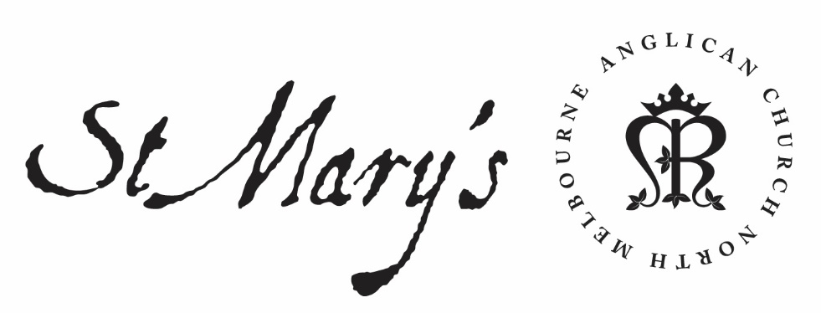

Wednesday Morning Prayer

3 March 2020

Wednesday Morning
Rejoice always; pray without ceasing;
in everything give thanks;
for this is the will of God in Christ Jesus.
1 Thessalonians 5.16–18

Glory to God; Father, Son and Holy Spirit:
as in the beginning, so now, and for ever. Amen.

The Opening Canticle, A Song of God’s Grace
Blessed are you,
the God and Father of our Lord Jesus Christ:
for you have blessed us in Christ Jesus
with every spiritual blessing in the heavenly places.
You chose us to be yours in Christ
before the foundation of the world:
that we should be holy and blameless before you.
In love you destined us to be your children,
through Jesus Christ:
according to the purpose of your will,
To the praise of your glorious grace:
which you freely bestowed on us in the Beloved.
Ephesians 1.3–6

The Opening Prayer
The night has passed and the day lies open before us;
let us pray with one heart and mind.

As we rejoice in the gift of this new day,
so may the light of your presence, O God,
set our hearts on fire with love for you;
now and for ever.
Amen.

Psalm 9
¹ I will give you thanks, O Lord, with my whole heart:
I will tell of all the wonders you have done.
² I will rejoice and be glad in you:
I will make my songs to your name, O Most High.
³ For my enemies are driven back:
they stumble and perish at your presence.
⁴ You have maintained my cause and my right:
you sat enthroned as a righteous judge.
⁵ You rebuked the heathen nations,
you brought the wicked to destruction:
you blotted out their name for ever and ever.
⁶ The strongholds of the enemy are made
a perpetual desolation:
you plucked up their cities,
and even their memory has perished.
⁷ The Lord confounds them; but the Lord endures
for ever:
he has set up his throne for judgement.
⁸ He shall judge the world with righteousness:
and deal true justice to the peoples.
⁹ The Lord is a strong tower to those that are oppressed:
he is a tower of strength in time of need.
¹⁰ All who heed your name will trust in you:
for you have never forsaken those that seek you.
¹¹ O sing praises to the Lord who dwells in Zion:
tell among the peoples what great things he has done.
¹² For he that avenges blood has remembered the poor:
he has not forgotten their cry.
¹³ The Lord has been merciful toward me,
he saw what I suffered from my foes:
he raised me up again from the gates of death,
¹⁴ That I might tell all your praises in the gates of Zion:
that I might rejoice in your deliverance.
¹⁵ The nations have sunk into the pit they dug for others:
in the very snare they laid is their foot taken;
¹⁶ The Lord has declared himself and upheld the right:
the wicked are trapped in the work of their own hands.
¹⁷ The wicked shall be given over to death:
and all the nations that forget God.
¹⁸ For the needy shall not always be forgotten:
nor shall the hope of the poor perish for ever.
¹⁹ Arise, Lord, let no human power prevail:
let the nations be judged before you.
²⁰ Put them in fear, O Lord:
and let the nations know they are but human.

We consecrate this day to your service, O Lord; may all our thoughts, words, and actions be well-pleasing to you and serve the good of our brothers and sisters; through Jesus Christ, our Lord. Amen.

1st Reading
Genesis 44.1-17
¹ Then he commanded the steward of his house, ‘Fill the men’s sacks with food, as much as they can carry, and put each man’s money in the top of his sack. ² Put my cup, the silver cup, in the top of the sack of the youngest, with his money for the grain.’ And he did as Joseph told him. ³ As soon as the morning was light, the men were sent away with their donkeys. ⁴ When they had gone only a short distance from the city, Joseph said to his steward, ‘Go, follow after the men; and when you overtake them, say to them, “Why have you returned evil for good? Why have you stolen my silver cup? ⁵ Is it not from this that my lord drinks? Does he not indeed use it for divination? You have done wrong in doing this.” ’ ⁶ When he overtook them, he repeated these words to them. ⁷ They said to him, ‘Why does my lord speak such words as these? Far be it from your servants that they should do such a thing! ⁸ Look, the money that we found at the top of our sacks, we brought back to you from the land of Canaan; why then would we steal silver or gold from your lord’s house? ⁹ Should it be found with any one of your servants, let him die; moreover, the rest of us will become my lord’s slaves.’ ¹⁰ He said, ‘Even so; in accordance with your words, let it be: he with whom it is found shall become my slave, but the rest of you shall go free.’ ¹¹ Then each one quickly lowered his sack to the ground, and each opened his sack. ¹² He searched, beginning with the eldest and ending with the youngest; and the cup was found in Benjamin’s sack. ¹³ At this they tore their clothes. Then each one loaded his donkey, and they returned to the city. ¹⁴ Judah and his brothers came to Joseph’s house while he was still there; and they fell to the ground before him. ¹⁵ Joseph said to them, ‘What deed is this that you have done? Do you not know that one such as I can practise divination?’ ¹⁶ And Judah said, ‘What can we say to my lord? What can we speak? How can we clear ourselves? God has found out the guilt of your servants; here we are then, my lord’s slaves, both we and also the one in whose possession the cup has been found.’ ¹⁷ But he said, ‘Far be it from me that I should do so! Only the one in whose possession the cup was found shall be my slave; but as for you, go up in peace to your father.’

2nd Reading
Luke 13.10-21
¹⁰ Now he was teaching in one of the synagogues on the sabbath. ¹¹ And just then there appeared a woman with a spirit that had crippled her for eighteen years. She was bent over and was quite unable to stand up straight. ¹² When Jesus saw her, he called her over and said, ‘Woman, you are set free from your ailment.’ ¹³ When he laid his hands on her, immediately she stood up straight and began praising God. ¹⁴ But the leader of the synagogue, indignant because Jesus had cured on the sabbath, kept saying to the crowd, ‘There are six days on which work ought to be done; come on those days and be cured, and not on the sabbath day.’ ¹⁵ But the Lord answered him and said, ‘You hypocrites! Does not each of you on the sabbath untie his ox or his donkey from the manger, and lead it away to give it water? ¹⁶ And ought not this woman, a daughter of Abraham whom Satan bound for eighteen long years, be set free from this bondage on the sabbath day?’ ¹⁷ When he said this, all his opponents were put to shame; and the entire crowd was rejoicing at all the wonderful things that he was doing. ¹⁸ He said therefore, ‘What is the kingdom of God like? And to what should I compare it? ¹⁹ It is like a mustard seed that someone took and sowed in the garden; it grew and became a tree, and the birds of the air made nests in its branches.’ ²⁰ And again he said, ‘To what should I compare the kingdom of God? ²¹ It is like yeast that a woman took and mixed in with three measures of flour until all of it was leavened.’

May your word live in us
and bear much fruit to your glory.

The Canticle, Te Deum Laudamus
We praise you, O God:
we acclaim you as Lord.
All creation worships you:
the Father everlasting.
To you all angels, all the powers of heaven:
the cherubim and seraphim, sing in endless praise:
Holy, holy, holy Lord, God of power and might:
heaven and earth are full of your glory.
The glorious company of apostles praise you:
The noble fellowship of prophets praise you.
The white-robed army of martyrs praise you:
Throughout the world, the holy Church acclaims you:
Father, of majesty unbounded:
your true and only Son, worthy of all praise,
the Holy Spirit, advocate and guide.
You, Christ, are the King of glory:
the eternal Son of the Father.
When you took our flesh to set us free:
you humbly chose the virgin’s womb.
You overcame the sting of death:
and opened the kingdom of heaven to all believers.
You are seated at God’s right hand in glory:
We believe that you will come to be our judge.
Come then, Lord, and help your people,
bought with the price of your own blood:
and bring us with your saints
to glory everlasting.

Lord have mercy.
Christ have mercy.
Lord have mercy.

The Lord’s Prayer
Our Father in heaven,
hallowed be your name,
your kingdom come,
your will be done,
on earth as in heaven.
Give us today our daily bread.
Forgive us our sins
as we forgive those who sin against us.
Save us from the time of trial
and deliver us from evil.
For the kingdom, the power, and the glory are yours
now and for ever. Amen.

Prayer of the day
Remember, O Lord,
what you have wrought in us
and not what we deserve,
and, as you have called us to your service,
make us worthy of our calling;
through Jesus Christ our Lord. Amen.

Intercessions and Thanksgivings may be made according to local custom and need.

The Morning Collect
Eternal God and Father,
by whose power we are created
and by whose love we are redeemed;
guide and strengthen us by your Spirit,
that we may give ourselves to your service,
and live this day in love
to one another and to you;
through Jesus Christ our Lord.
Amen.

The Lord be with you.
And also with you.
Let us praise the Lord.
Thanks be to God.

May the God of steadfastness and encouragement grant us to live in such harmony with one another in accord with Christ Jesus, that we may with one voice glorify our God and Father. Amen.
Romans 15.5–6

