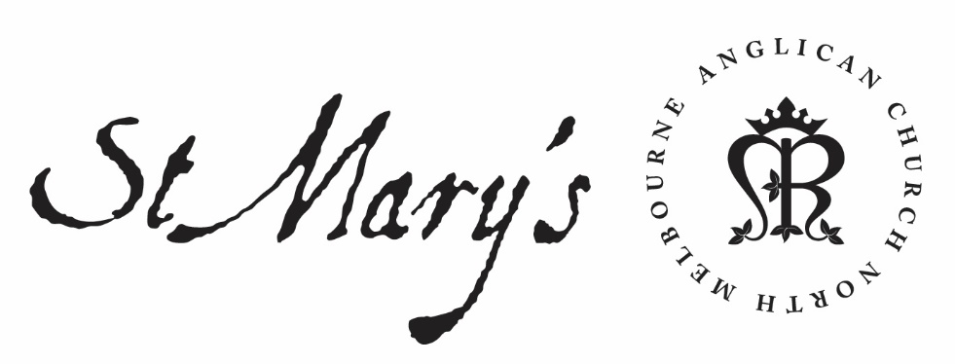

Monday Morning Prayer

15 March 2021

Monday Morning
God’s love has been poured into our hearts,
through the Holy Spirit who has been given to us.
Romans 5.5

Glory to God; Father, Son and Holy Spirit:
as in the beginning, so now, and for ever. Amen.

The Opening Canticle
I will sing a new hymn to my God:
O Lord you are great and marvellous,
you are marvellous in your strength, invincible.
Let the whole creation serve you:
for you spoke and all things came to be;
You sent out your Spirit and it formed them:
no one can resist your voice.
Mountains and seas are stirred to their depths:
rocks melt like wax at your presence;
But to those who revere you:
you still show mercy.
Judith 16.13–15

The Opening Prayer
The night has passed and the day lies open before us;
let us pray with one heart and mind.

As we rejoice in the gift of this new day,
so may the light of your presence, O God,
set our hearts on fire with love for you;
now and for ever.
Amen.

Psalm 37.1-17
¹ Do not vie with the wicked:
or envy those that do wrong;
² For they will soon wither like the grass:
and fade away like the green leaf.
³ Trust in the Lord and do good:
and you shall dwell in the land
and feed in safe pastures.
⁴ Let the Lord be your delight:
and he will grant you your heart’s desire.
⁵ Commit your way to the Lord:
trust him, and he will act.
⁶ He will make your righteousness
shine as clear as the light:
and your innocence as the noonday.
⁷ Be still before the Lord, and wait patiently for him:
do not be vexed when someone prospers,
when they put their evil purposes to work.
⁸ Let go of anger and abandon wrath:
let not envy move you to do evil.
⁹ For the wicked shall be cut down:
but those who wait for the Lord shall possess the land.
¹⁰ In a little while the ungodly shall be no more:
you will look for them in their place,
but they will not be found.
¹¹ But the meek shall possess the land:
and enjoy the abundance of peace.
¹² The ungodly plot against the righteous:
and gnash at them with their teeth.
¹³ But the Lord shall laugh them to scorn:
for he sees that the day for their overthrow is near.
¹⁴ The ungodly have drawn the sword and strung the bow:
to strike down the poor and needy,
to slaughter those that walk in innocence.
¹⁵ Their swords shall pierce their own hearts:
and their bows shall be broken.
¹⁶ Though the righteous has but a little:
it is better than the great wealth of the ungodly.
¹⁷ For the strong arm of the ungodly shall be broken:
but the Lord upholds the righteous.

Creator Spirit, Advocate promised by our Lord Jesus: increase our faith and help us to walk in the light of your presence, to the glory of God the Father; through Jesus Christ our Lord. Amen.

1st Reading
Exodus 1
¹ These are the names of the sons of Israel who came to Egypt with Jacob, each with his household: ² Reuben, Simeon, Levi, and Judah, ³ Issachar, Zebulun, and Benjamin, ⁴ Dan and Naphtali, Gad and Asher. ⁵ The total number of people born to Jacob was seventy. Joseph was already in Egypt. ⁶ Then Joseph died, and all his brothers, and that whole generation. ⁷ But the Israelites were fruitful and prolific; they multiplied and grew exceedingly strong, so that the land was filled with them. ⁸ Now a new king arose over Egypt, who did not know Joseph. ⁹ He said to his people, ‘Look, the Israelite people are more numerous and more powerful than we. ¹⁰ Come, let us deal shrewdly with them, or they will increase and, in the event of war, join our enemies and fight against us and escape from the land.’ ¹¹ Therefore they set taskmasters over them to oppress them with forced labour. They built supply cities, Pithom and Rameses, for Pharaoh. ¹² But the more they were oppressed, the more they multiplied and spread, so that the Egyptians came to dread the Israelites. ¹³ The Egyptians became ruthless in imposing tasks on the Israelites, ¹⁴ and made their lives bitter with hard service in mortar and brick and in every kind of field labour. They were ruthless in all the tasks that they imposed on them. ¹⁵ The king of Egypt said to the Hebrew midwives, one of whom was named Shiphrah and the other Puah, ¹⁶ ‘When you act as midwives to the Hebrew women, and see them on the birthstool, if it is a boy, kill him; but if it is a girl, she shall live.’ ¹⁷ But the midwives feared God; they did not do as the king of Egypt commanded them, but they let the boys live. ¹⁸ So the king of Egypt summoned the midwives and said to them, ‘Why have you done this, and allowed the boys to live?’ ¹⁹ The midwives said to Pharaoh, ‘Because the Hebrew women are not like the Egyptian women; for they are vigorous and give birth before the midwife comes to them.’ ²⁰ So God dealt well with the midwives; and the people multiplied and became very strong. ²¹ And because the midwives feared God, he gave them families. ²² Then Pharaoh commanded all his people, ‘Every boy that is born to the Hebrews you shall throw into the Nile, but you shall let every girl live.’

2nd Reading
Luke 18.1-14
¹ Then Jesus told them a parable about their need to pray always and not to lose heart. ² He said, ‘In a certain city there was a judge who neither feared God nor had respect for people. ³ In that city there was a widow who kept coming to him and saying, “Grant me justice against my opponent.” ⁴ For a while he refused; but later he said to himself, “Though I have no fear of God and no respect for anyone, ⁵ yet because this widow keeps bothering me, I will grant her justice, so that she may not wear me out by continually coming.” ’ ⁶ And the Lord said, ‘Listen to what the unjust judge says. ⁷ And will not God grant justice to his chosen ones who cry to him day and night? Will he delay long in helping them? ⁸ I tell you, he will quickly grant justice to them. And yet, when the Son of Man comes, will he find faith on earth?’ ⁹ He also told this parable to some who trusted in themselves that they were righteous and regarded others with contempt: ¹⁰ ‘Two men went up to the temple to pray, one a Pharisee and the other a tax-collector. ¹¹ The Pharisee, standing by himself, was praying thus, “God, I thank you that I am not like other people: thieves, rogues, adulterers, or even like this tax-collector. ¹² I fast twice a week; I give a tenth of all my income.” ¹³ But the tax-collector, standing far off, would not even look up to heaven, but was beating his breast and saying, “God, be merciful to me, a sinner!” ¹⁴ I tell you, this man went down to his home justified rather than the other; for all who exalt themselves will be humbled, but all who humble themselves will be exalted.’

May your word live in us
and bear much fruit to your glory.

The Canticle, A Song of Isiah
‘Behold, God is my salvation:
I will trust and will not be afraid;
‘For the Lord God is my strength and my song:
and has become my salvation.’
With joy you will draw water:
from the wells of salvation.
On that day you will say:
‘Give thanks to the Lord, call upon his name;
‘Make known his deeds among the nations:
proclaim that his name is exalted.
‘Sing God’s praises, who has triumphed gloriously:
let this be known in all the world.
‘Shout and sing for joy, you that dwell in Zion:
for great in your midst is the Holy One of Israel.’
Isaiah 12.2–6

Lord have mercy.
Christ have mercy.
Lord have mercy.

The Lord’s Prayer
Our Father in heaven,
hallowed be your name,
your kingdom come,
your will be done,
on earth as in heaven.
Give us today our daily bread.
Forgive us our sins
as we forgive those who sin against us.
Save us from the time of trial
and deliver us from evil.
For the kingdom, the power, and the glory are yours
now and for ever. Amen.

Prayer of the Day
Almighty God,
in Christ you make all things new:
transform the poverty of our nature
by the riches of your grace,
and in the renewal of our lives
make known your heavenly glory;
through Jesus Christ our Lord. Amen.

Intercessions and Thanksgivings may be made according to local custom and need.

The Morning Collect
Eternal God and Father,
by whose power we are created
and by whose love we are redeemed;
guide and strengthen us by your Spirit,
that we may give ourselves to your service,
and live this day in love
to one another and to you;
through Jesus Christ our Lord.
Amen.

The Lord be with you.
And also with you.
Let us praise the Lord.
Thanks be to God.

God did not give us a spirit of cowardice
but a spirit of power and of love and of self-discipline.
May we rekindle the gift of God within us. Amen.
2 Timothy 1.6–7

