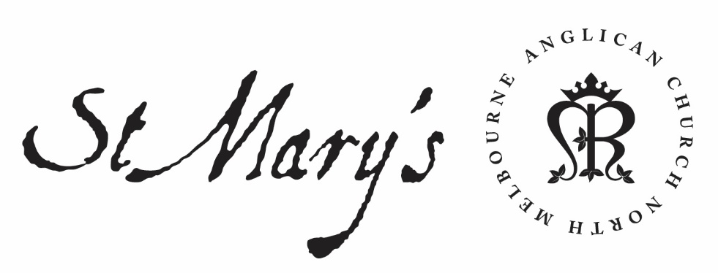

Friday Morning Prayer

19 March 2021

Joseph

Friday Morning
Through Christ let us offer up a sacrifice of praise to God,
the fruit of lips that acknowledge his name.
Hebrews 13.15

Glory to God; Father, Son and Holy Spirit:
as in the beginning, so now, and for ever. Amen.

The Opening Canticle, A Song of God’s Grace
We have complete freedom:
to go into the most holy place by means of the death of Jesus.
He opened for us a new way, a living way:
through the curtain, through his own body.
Since we have a great high priest
set over the household of God:
let us draw near with a sincere heart and a sure faith,
With hearts that have been made clean
from a guilty conscience:
and bodies washed with pure water.
Hebrews 10.19–22

The Opening Prayer
The night has passed and the day lies open before us;
let us pray with one heart and mind.

As we rejoice in the gift of this new day,
so may the light of your presence, O God,
set our hearts on fire with love for you;
now and for ever.
Amen.

Psalm 1
¹ Blessed are they
who have not walked in the counsel of the ungodly:
nor followed the way of sinners,
nor taken their seat amongst the scornful.
² But their delight is in the law of the Lord:
and on that law will they ponder day and night.
³ They are like trees planted beside streams of water:
that yield their fruit in due season.
⁴ Their leaves also shall not wither:
and look, whatever they do, it shall prosper.
⁵ As for the ungodly, it is not so with them:
they are like the chaff which the wind scatters.
⁶ Therefore the ungodly shall not stand up
at the judgement:
nor sinners in the congregation of the righteous.
⁷ For the Lord cares for the way of the righteous:
but the way of the ungodly shall perish.

Holy God, through your beloved Son you reconciled all things to yourself, making peace by the blood of his cross: fill us and those for whom we pray with your peace and joy; through Jesus Christ our Lord. Amen.

1st Reading
Joel 2.27-32
²⁷ You shall know that I am in the midst of Israel,
and that I, the Lord , am your God and there is no other.
And my people shall never again
be put to shame.
²⁸ Then afterwards
I will pour out my spirit on all flesh;
your sons and your daughters shall prophesy,
your old men shall dream dreams,
and your young men shall see visions.
²⁹ Even on the male and female slaves,
in those days, I will pour out my spirit.
³⁰ I will show portents in the heavens and on the earth, blood and fire and columns of smoke.
³¹ The sun shall be turned to darkness, and the moon to blood, before the great and terrible day of the Lord comes.
³² Then everyone who calls on the name of the Lord shall be saved; for in Mount Zion and in Jerusalem there shall be those who escape, as the Lord has said, and among the survivors shall be those whom the Lord calls.

2nd Reading
Ephesians 6.1-4
¹ Children, obey your parents in the Lord, for this is right. ² ‘Honour your father and mother’—this is the first commandment with a promise: ³ ‘so that it may be well with you and you may live long on the earth.’ ⁴ And, fathers, do not provoke your children to anger, but bring them up in the discipline and instruction of the Lord.

May your word live in us
and bear much fruit to your glory.

The Canticle, Saviour of the World
Jesus, Saviour of the world,
come to us in your mercy:
we look to you to save and help us.
By your cross and your life laid down,
you set your people free:
we look to you to save and help us.
When they were ready to perish,
you saved your disciples:
we look to you to come to our help.
In the greatness of your mercy,
loose us from our chains:
forgive the sins of all your people.
Make yourself known as our saviour
and mighty deliverer:
save and help us that we may praise you.
Come now and dwell with us, Lord Christ Jesus:
hear our prayer and be with us always.
And when you come in your glory:
make us to be one with you
and to share the life of your kingdom.

Lord have mercy.
Christ have mercy.
Lord have mercy.

The Lord’s Prayer
Our Father in heaven,
hallowed be your name,
your kingdom come,
your will be done,
on earth as in heaven.
Give us today our daily bread.
Forgive us our sins
as we forgive those who sin against us.
Save us from the time of trial
and deliver us from evil.
For the kingdom, the power, and the glory are yours
now and for ever. Amen.

Prayer of the Day: Joseph, Husband of the Blessed Virgin Mary
O God,
who from the line of your servant David
raised up the carpenter Joseph
to be the guardian of your incarnate Son
and the husband of Mary his virgin mother:
give us grace to follow Joseph’s integrity of life
and his obedience to your commands;
through Jesus Christ our Lord,
who lives and reigns with you and the Holy Spirit,
one God, for ever and ever. Amen.

Intercessions and Thanksgivings may be made according to local custom and need.

The Morning Collect
Eternal God and Father,
by whose power we are created
and by whose love we are redeemed;
guide and strengthen us by your Spirit,
that we may give ourselves to your service,
and live this day in love
to one another and to you;
through Jesus Christ our Lord.
Amen.

The Lord be with you.
And also with you.
Let us praise the Lord.
Thanks be to God.

Peace be to us all, and love with faith, from God the Father and the Lord Jesus Christ.
Amen.
Ephesians 6.23

