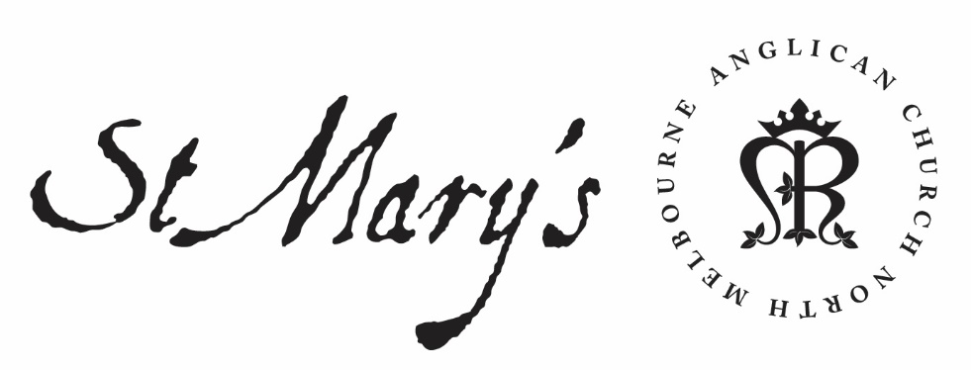

Monday Morning Prayer

22 March 2021

Monday Morning
God’s love has been poured into our hearts,
through the Holy Spirit who has been given to us.
Romans 5.5

Glory to God; Father, Son and Holy Spirit:
as in the beginning, so now, and for ever. Amen.

The Opening Canticle
I will sing a new hymn to my God:
O Lord you are great and marvellous,
you are marvellous in your strength, invincible.
Let the whole creation serve you:
for you spoke and all things came to be;
You sent out your Spirit and it formed them:
no one can resist your voice.
Mountains and seas are stirred to their depths:
rocks melt like wax at your presence;
But to those who revere you:
you still show mercy.
Judith 16.13–15

The Opening Prayer
The night has passed and the day lies open before us;
let us pray with one heart and mind.

As we rejoice in the gift of this new day,
so may the light of your presence, O God,
set our hearts on fire with love for you;
now and for ever.
Amen.

Psalm 51
¹ Have mercy on me, O God, in your enduring goodness:
according to the fulness of your compassion
blot out my offences.
² Wash me thoroughly from my wickedness:
and cleanse me from my sin.
³ For I acknowledge my rebellion:
and my sin is ever before me.
⁴ Against you only have I sinned
and done what is evil in your eyes:
so you will be just in your sentence
and blameless in your judging.
⁵ Surely in wickedness I was brought to birth:
and in sin my mother conceived me.
⁶ You that desire truth in the inward parts:
O teach me wisdom in the secret places of the heart.
⁷ Purge me with hyssop, and I shall be clean:
wash me, and I shall be whiter than snow.
⁸ Make me hear of joy and gladness:
let the bones which you have broken rejoice.
⁹ Hide your face from my sins:
and blot out all my iniquities.
¹⁰ Create in me a clean heart, O God:
and renew a right spirit within me.
¹¹ Do not cast me out from your presence:
do not take your holy spirit from me.
¹² O give me the gladness of your help again:
and support me with a willing spirit.
¹³ Then will I teach transgressors your ways:
and sinners shall turn to you again.
¹⁴ O Lord God of my salvation, deliver me from bloodshed:
and my tongue shall sing of your righteousness.
¹⁵ O Lord, open my lips:
and my mouth shall proclaim your praise.
¹⁶ You take no pleasure in sacrifice, or I would give it:
burnt-offerings you do not want.
¹⁷ The sacrifice of God is a broken spirit:
a broken and contrite heart, O God, you will not despise.
¹⁸ In your graciousness do good to Zion:
rebuild the walls of Jerusalem.
¹⁹ Then will you delight in right sacrifices,
in burnt-offerings and oblations:
then will they offer young bulls upon your altar.

Creator Spirit, Advocate promised by our Lord Jesus: increase our faith and help us to walk in the light of your presence, to the glory of God the Father; through Jesus Christ our Lord. Amen.

1st Reading
Exodus 7.8-24
⁸ The Lord said to Moses and Aaron, ⁹ ‘When Pharaoh says to you, “Perform a wonder”, then you shall say to Aaron, “Take your staff and throw it down before Pharaoh, and it will become a snake.” ’ ¹⁰ So Moses and Aaron went to Pharaoh and did as the Lord had commanded; Aaron threw down his staff before Pharaoh and his officials, and it became a snake. ¹¹ Then Pharaoh summoned the wise men and the sorcerers; and they also, the magicians of Egypt, did the same by their secret arts. ¹² Each one threw down his staff, and they became snakes; but Aaron’s staff swallowed up theirs. ¹³ Still Pharaoh’s heart was hardened, and he would not listen to them, as the Lord had said. ¹⁴ Then the Lord said to Moses, ‘Pharaoh’s heart is hardened; he refuses to let the people go. ¹⁵ Go to Pharaoh in the morning, as he is going out to the water; stand by at the river bank to meet him, and take in your hand the staff that was turned into a snake. ¹⁶ Say to him, “The Lord , the God of the Hebrews, sent me to you to say, ‘Let my people go, so that they may worship me in the wilderness.’ But until now you have not listened. ¹⁷ Thus says the Lord , ‘By this you shall know that I am the Lord .’ See, with the staff that is in my hand I will strike the water that is in the Nile, and it shall be turned to blood. ¹⁸ The fish in the river shall die, the river itself shall stink, and the Egyptians shall be unable to drink water from the Nile.” ’ ¹⁹ The Lord said to Moses, ‘Say to Aaron, “Take your staff and stretch out your hand over the waters of Egypt—over its rivers, its canals, and its ponds, and all its pools of water—so that they may become blood; and there shall be blood throughout the whole land of Egypt, even in vessels of wood and in vessels of stone.” ’ ²⁰ Moses and Aaron did just as the Lord commanded. In the sight of Pharaoh and of his officials he lifted up the staff and struck the water in the river, and all the water in the river was turned into blood, ²¹ and the fish in the river died. The river stank so that the Egyptians could not drink its water, and there was blood throughout the whole land of Egypt. ²² But the magicians of Egypt did the same by their secret arts; so Pharaoh’s heart remained hardened, and he would not listen to them, as the Lord had said. ²³ Pharaoh turned and went into his house, and he did not take even this to heart. ²⁴ And all the Egyptians had to dig along the Nile for water to drink, for they could not drink the water of the river.

2nd Reading
Luke 20.1-18
¹ One day, as he was teaching the people in the temple and telling the good news, the chief priests and the scribes came with the elders
² and said to him, ‘Tell us, by what authority are you doing these things? Who is it who gave you this authority?’
³ He answered them, ‘I will also ask you a question, and you tell me:
⁴ Did the baptism of John come from heaven, or was it of human origin?’
⁵ They discussed it with one another, saying, ‘If we say, “From heaven”, he will say, “Why did you not believe him?”
⁶ But if we say, “Of human origin”, all the people will stone us; for they are convinced that John was a prophet.’
⁷ So they answered that they did not know where it came from.
⁸ Then Jesus said to them, ‘Neither will I tell you by what authority I am doing these things.’
⁹ He began to tell the people this parable: ‘A man planted a vineyard, and leased it to tenants, and went to another country for a long time.
¹⁰ When the season came, he sent a slave to the tenants in order that they might give him his share of the produce of the vineyard; but the tenants beat him and sent him away empty-handed.
¹¹ Next he sent another slave; that one also they beat and insulted and sent away empty-handed.
¹² And he sent yet a third; this one also they wounded and threw out.
¹³ Then the owner of the vineyard said, “What shall I do? I will send my beloved son; perhaps they will respect him.”
¹⁴ But when the tenants saw him, they discussed it among themselves and said, “This is the heir; let us kill him so that the inheritance may be ours.”
¹⁵ So they threw him out of the vineyard and killed him. What then will the owner of the vineyard do to them?
¹⁶ He will come and destroy those tenants and give the vineyard to others.’ When they heard this, they said, ‘Heaven forbid!’
¹⁷ But he looked at them and said, ‘What then does this text mean:
“The stone that the builders rejected
has become the cornerstone”?
¹⁸ Everyone who falls on that stone will be broken to pieces; and it will crush anyone on whom it falls.’

May your word live in us
and bear much fruit to your glory.

The Canticle, A Song of Isiah
‘Behold, God is my salvation:
I will trust and will not be afraid;
‘For the Lord God is my strength and my song:
and has become my salvation.’
With joy you will draw water:
from the wells of salvation.
On that day you will say:
‘Give thanks to the Lord, call upon his name;
‘Make known his deeds among the nations:
proclaim that his name is exalted.
‘Sing God’s praises, who has triumphed gloriously:
let this be known in all the world.
‘Shout and sing for joy, you that dwell in Zion:
for great in your midst is the Holy One of Israel.’
Isaiah 12.2–6

Lord have mercy.
Christ have mercy.
Lord have mercy.

The Lord’s Prayer
Our Father in heaven,
hallowed be your name,
your kingdom come,
your will be done,
on earth as in heaven.
Give us today our daily bread.
Forgive us our sins
as we forgive those who sin against us.
Save us from the time of trial
and deliver us from evil.
For the kingdom, the power, and the glory are yours
now and for ever. Amen.

Prayer of the Day
We thank you, heavenly Father,
that you have delivered us from the power of darkness
and brought us into the kingdom of your Son:
we pray that
as by his death he has recalled us to life,
so by his presence abiding in us he may raise us
to joys eternal;
through Jesus Christ your Son our Lord,
who lives and reigns with you in the unity of the Holy Spirit,
one God, now and for ever. Amen.

Intercessions and Thanksgivings may be made according to local custom and need.

The Morning Collect
Eternal God and Father,
by whose power we are created
and by whose love we are redeemed;
guide and strengthen us by your Spirit,
that we may give ourselves to your service,
and live this day in love
to one another and to you;
through Jesus Christ our Lord.
Amen.

The Lord be with you.
And also with you.
Let us praise the Lord.
Thanks be to God.

God did not give us a spirit of cowardice
but a spirit of power and of love and of self-discipline.
May we rekindle the gift of God within us. Amen.
2 Timothy 1.6–7

