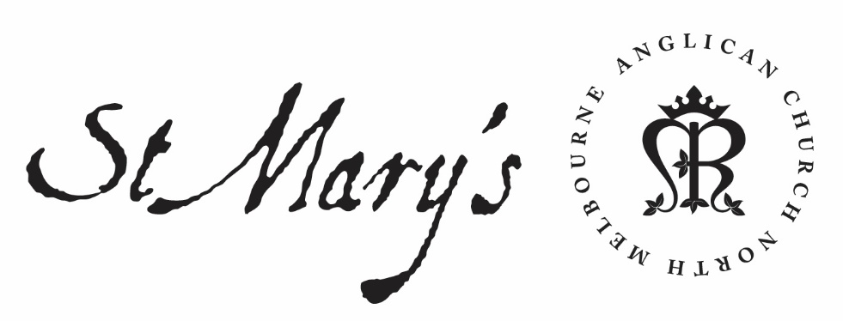

Wednesday Morning Prayer

24 March 2020

Oscar Romero, archbishop of San Salvador, martyr (d. 1980)

Wednesday Morning

Rejoice always; pray without ceasing;
in everything give thanks;
for this is the will of God in Christ Jesus.
1 Thessalonians 5.16–18

Glory to God; Father, Son and Holy Spirit:
as in the beginning, so now, and for ever. Amen.

The Opening Canticle, A Song of God’s Grace
Blessed are you,
the God and Father of our Lord Jesus Christ:
for you have blessed us in Christ Jesus
with every spiritual blessing in the heavenly places.
You chose us to be yours in Christ
before the foundation of the world:
that we should be holy and blameless before you.
In love you destined us to be your children,
through Jesus Christ:
according to the purpose of your will,
To the praise of your glorious grace:
which you freely bestowed on us in the Beloved.
Ephesians 1.3–6

The Opening Prayer
The night has passed and the day lies open before us;
let us pray with one heart and mind.

As we rejoice in the gift of this new day,
so may the light of your presence, O God,
set our hearts on fire with love for you;
now and for ever.
Amen.

Psalms 56; 57

56
¹ Be merciful to me, O God, for they are treading me down:
all day long my adversary presses upon me.
² My enemies tread me down all the day:
for there are many that arrogantly fight against me.
³ In the hour of fear:
I will put my trust in you.
⁴ In God, whose word I praise, in God I trust and fear not:
what can flesh do to me?
⁵ All day long they afflict me with their words:
and every thought is how to do me evil.
⁶ They stir up hatred and conceal themselves:
they watch my steps, while they lie in wait for my life.
⁷ Let there be no escape for them:
bring down the peoples in your wrath, O God.
⁸ You have counted my anxious tossings;
put my tears in your bottle:
are not these things noted in your book?
⁹ In the day that I call to you, my enemies shall turn back:
this I know, for God is with me.
10 In God, whose word I praise,
in God I trust and fear not:
what can flesh and blood do to me?
¹¹ To you, O God, must I perform my vows:
I will pay the thank-offering that is due.
¹² For you will deliver my soul from death,
and my feet from falling:
that I may walk before God in the light of the living.

57
¹ Be merciful to me, O God, be merciful:
for I come to you for shelter;
² And in the shadow of your wings will I take refuge:
until these troubles are over-past.
³ I will call to God Most High:
to the God who will fulfil his purpose for me.
⁴ He will send from heaven and save me:
he will send forth his faithfulness
and his loving-kindness,
and rebuke those that would trample me down.
⁵ For I lie amidst ravening lions:
those whose teeth are spears and arrows,
and their tongue a sharpened sword.
⁶ Be exalted, O God, above the heavens:
and let your glory be over all the earth.
⁷ They have set a net for my feet, and I am brought low:
they have dug a pit before me,
but shall fall into it themselves.
⁸ My heart is fixed, O God, my heart is fixed:
I will sing and make melody.
⁹ Awake my soul, awake lute and harp:
for I will awaken the morning.
¹⁰ I will give you thanks, O Lord, among the peoples:
I will sing your praise among the nations.
¹¹ For the greatness of your mercy reaches to the heavens:
and your faithfulness to the clouds.
¹² Be exalted, O God, above the heavens:
and let your glory be over all the earth.

We consecrate this day to your service, O Lord; may all our thoughts, words, and actions be well-pleasing to you and serve the good of our brothers and sisters; through Jesus Christ, our Lord. Amen.

1st Reading
Exodus 8.20-9.12
8 ²⁰ Then the Lord said to Moses, ‘Rise early in the morning and present yourself before Pharaoh, as he goes out to the water, and say to him, “Thus says the Lord : Let my people go, so that they may worship me. ²¹ For if you will not let my people go, I will send swarms of flies on you, your officials, and your people, and into your houses; and the houses of the Egyptians shall be filled with swarms of flies; so also the land where they live. ²² But on that day I will set apart the land of Goshen, where my people live, so that no swarms of flies shall be there, that you may know that I the Lord am in this land. ²³ Thus I will make a distinction between my people and your people. This sign shall appear tomorrow.” ’ ²⁴ The Lord did so, and great swarms of flies came into the house of Pharaoh and into his officials’ houses; in all of Egypt the land was ruined because of the flies. ²⁵ Then Pharaoh summoned Moses and Aaron, and said, ‘Go, sacrifice to your God within the land.’ ²⁶ But Moses said, ‘It would not be right to do so; for the sacrifices that we offer to the Lord our God are offensive to the Egyptians. If we offer in the sight of the Egyptians sacrifices that are offensive to them, will they not stone us? ²⁷ We must go a three days’ journey into the wilderness and sacrifice to the Lord our God as he commands us.’ ²⁸ So Pharaoh said, ‘I will let you go to sacrifice to the Lord your God in the wilderness, provided you do not go very far away. Pray for me.’ ²⁹ Then Moses said, ‘As soon as I leave you, I will pray to the Lord that the swarms of flies may depart tomorrow from Pharaoh, from his officials, and from his people; only do not let Pharaoh again deal falsely by not letting the people go to sacrifice to the Lord .’ ³⁰ So Moses went out from Pharaoh and prayed to the Lord . ³¹ And the Lord did as Moses asked: he removed the swarms of flies from Pharaoh, from his officials, and from his people; not one remained. ³² But Pharaoh hardened his heart this time also, and would not let the people go. 9 ¹ Then the Lord said to Moses, ‘Go to Pharaoh, and say to him, “Thus says the Lord , the God of the Hebrews: Let my people go, so that they may worship me. ² For if you refuse to let them go and still hold them, ³ the hand of the Lord will strike with a deadly pestilence your livestock in the field: the horses, the donkeys, the camels, the herds, and the flocks. ⁴ But the Lord will make a distinction between the livestock of Israel and the livestock of Egypt, so that nothing shall die of all that belongs to the Israelites.” ’ ⁵ The Lord set a time, saying, ‘Tomorrow the Lord will do this thing in the land.’ ⁶ And on the next day the Lord did so; all the livestock of the Egyptians died, but of the livestock of the Israelites not one died. ⁷ Pharaoh inquired and found that not one of the livestock of the Israelites was dead. But the heart of Pharaoh was hardened, and he would not let the people go. ⁸ Then the Lord said to Moses and Aaron, ‘Take handfuls of soot from the kiln, and let Moses throw it in the air in the sight of Pharaoh. ⁹ It shall become fine dust all over the land of Egypt, and shall cause festering boils on humans and animals throughout the whole land of Egypt.’ ¹⁰ So they took soot from the kiln, and stood before Pharaoh, and Moses threw it in the air, and it caused festering boils on humans and animals. ¹¹ The magicians could not stand before Moses because of the boils, for the boils afflicted the magicians as well as all the Egyptians. ¹² But the Lord hardened the heart of Pharaoh, and he would not listen to them, just as the Lord had spoken to Moses.

2nd Reading
Luke 20.27-47
²⁷ Some Sadducees, those who say there is no resurrection, came to him
²⁸ and asked him a question, ‘Teacher, Moses wrote for us that if a man’s brother dies, leaving a wife but no children, the man shall marry the widow and raise up children for his brother.
²⁹ Now there were seven brothers; the first married, and died childless;
³⁰ then the second
³¹ and the third married her, and so in the same way all seven died childless.
³² Finally the woman also died.
³³ In the resurrection, therefore, whose wife will the woman be? For the seven had married her.’
³⁴ Jesus said to them, ‘Those who belong to this age marry and are given in marriage;
³⁵ but those who are considered worthy of a place in that age and in the resurrection from the dead neither marry nor are given in marriage.
³⁶ Indeed they cannot die any more, because they are like angels and are children of God, being children of the resurrection.
³⁷ And the fact that the dead are raised Moses himself showed, in the story about the bush, where he speaks of the Lord as the God of Abraham, the God of Isaac, and the God of Jacob.
³⁸ Now he is God not of the dead, but of the living; for to him all of them are alive.’
³⁹ Then some of the scribes answered, ‘Teacher, you have spoken well.’
⁴⁰ For they no longer dared to ask him another question.
⁴¹ Then he said to them, ‘How can they say that the Messiah is David’s son?
⁴² For David himself says in the book of Psalms,
“The Lord said to my Lord,
‘Sit at my right hand,
⁴³ until I make your enemies your footstool.’ ”
⁴⁴ David thus calls him Lord; so how can he be his son?’
⁴⁵ In the hearing of all the people he said to the disciples,
⁴⁶ ‘Beware of the scribes, who like to walk around in long robes, and love to be greeted with respect in the market-places, and to have the best seats in the synagogues and places of honour at banquets.
⁴⁷ They devour widows’ houses and for the sake of appearance say long prayers. They will receive the greater condemnation.’

May your word live in us
and bear much fruit to your glory.

The Canticle, Te Deum Laudamus
We praise you, O God:
we acclaim you as Lord.
All creation worships you:
the Father everlasting.
To you all angels, all the powers of heaven:
the cherubim and seraphim, sing in endless praise:
Holy, holy, holy Lord, God of power and might:
heaven and earth are full of your glory.
The glorious company of apostles praise you:
The noble fellowship of prophets praise you.
The white-robed army of martyrs praise you:
Throughout the world, the holy Church acclaims you:
Father, of majesty unbounded:
your true and only Son, worthy of all praise,
the Holy Spirit, advocate and guide.
You, Christ, are the King of glory:
the eternal Son of the Father.
When you took our flesh to set us free:
you humbly chose the virgin’s womb.
You overcame the sting of death:
and opened the kingdom of heaven to all believers.
You are seated at God’s right hand in glory:
We believe that you will come to be our judge.
Come then, Lord, and help your people,
bought with the price of your own blood:
and bring us with your saints
to glory everlasting.

Lord have mercy.
Christ have mercy.
Lord have mercy.

The Lord’s Prayer
Our Father in heaven,
hallowed be your name,
your kingdom come,
your will be done,
on earth as in heaven.
Give us today our daily bread.
Forgive us our sins
as we forgive those who sin against us.
Save us from the time of trial
and deliver us from evil.
For the kingdom, the power, and the glory are yours
now and for ever. Amen.

Prayer of the day
Almighty God,
who gave to your servant Oscar
boldness to confess the name of Jesus Christ
and courage to die for this faith:
teach us always to be ready
to give a reason for the hope that is in us,
and to suffer gladly for the sake of our Lord and Saviour;
who lives and reigns with you and the Holy Spirit,
one God, for ever and ever. Amen.

Intercessions and Thanksgivings may be made according to local custom and need.

The Morning Collect
Eternal God and Father,
by whose power we are created
and by whose love we are redeemed;
guide and strengthen us by your Spirit,
that we may give ourselves to your service,
and live this day in love
to one another and to you;
through Jesus Christ our Lord.
Amen.

The Lord be with you.
And also with you.
Let us praise the Lord.
Thanks be to God.

May the God of steadfastness and encouragement grant us to live in such harmony with one another in accord with Christ Jesus, that we may with one voice glorify our God and Father. Amen.
Romans 15.5–6

